Annual Curriculum Overview (2025 - 26)
 | Autumn A | Autumn B | Spring A | Spring B | Summer A | Summer B
Topic | Revolution/Investigating Our World |  | Dynamic Dynasties |  | Sow, Grow, Farm
Maths | White Rose  Planning |  | White Rose  Planning |  | White Rose  Planning
English  Literacy Shed | Predictions  Discussion  Diary Writing  Different perspectives  Narrative  Informal letter  Non – chronological report  Biography  Explanation  Poetry  Persuasive advert  Characterising speech  Recount letter |  | Character map  Newspaper report  Persuasive letter  Memoir  Biography  Explanation  Balanced argument (linked to environment)  Narrative  Suspense  Dilema  Description  Monolgue  Newspaper report  Persuasive leaflet  Instructions |  | Fact file  Narrative  Debate  Diary  Poetry  Biography  Playscript  Character description  Non chronological report  Persuasive letter  Discussion  Explanation
Text | - Holes by Louis Sachar  - Armistice Runner by Tom Palmer  - Street Child by Berlie Doherty  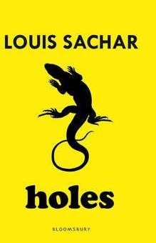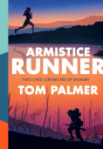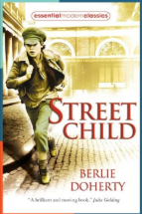 |  | - Hidden Figures by Margot Lee  - Everest by Alexander Stewart  - The Watertower by Gary Crew  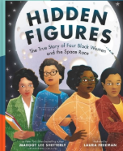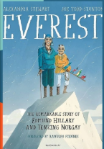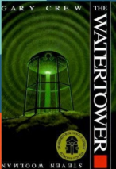 |  | - The Final Year by Mark Goodfellow  - Counting on Katherine by Helaine Becker  - The Tin Forest by Helen Ward  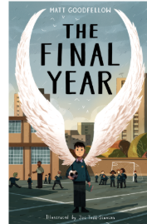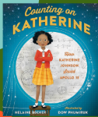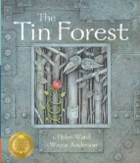
Guided Reading | October, October by Katya Balen  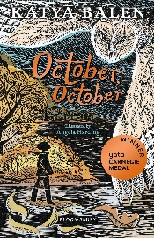 |  | Harklights by Tim Tilley  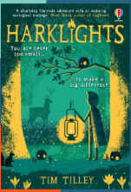 |  | Calling the Whales by Jasbinder Bilan  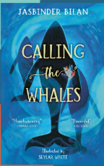
Science – Year 6  Cornerstones | Y6: Electrical Circuits and Components  - Series circuits  - Circuit components  - Recognised circuit symbols  - Investigating circuit components  - Electric current; Voltage  - Researching cells and batteries  - Investigating voltage changes  - Working scientifically  Living things and their habitats  - Give reasons for classifying plants and animals based on characteristics  - Describe how living things are classify into broad groups according to characteristics.  - Explore the work of Carl Linnaeus |  | Y6: Circulatory System  - Bodily systems  - Circulatory system – role and main parts  - Heart – structure and function  - Blood – components and functions  - Blood vessels – structure and function  - Measuring heart rate  - Proving a hypothesis  - Heart rate investigation  - Classifying foods  - Effects of smoking, alcohol and drugs  - Heart rate recovery investigation  - Working scientifically |  | Y6: Light Theory  - Light, sight and the human eye  - Visible light  - Perceiving colour  - Shadows and Reflections  - Plane, concave and convex mirrors  - Refraction  - Working scientifically  Evolution and Inheritance  - Five kingdoms, microorganisms and viruses  - Theory of evolution and evolutionary tree diagrams  - Inheritance and variation – continuous and discontinuous variation  - Natural selection and survival of the fittest  - Working scientifically
History  Cornerstones | Revolution  - The changing power of monarchs using case studies such as John, Anne and Victoria  - Daily life in Victorian era  - Cause and effect of significant figures (Sir Robert Peel)  - Ask and answer questions relating to topic  - Understand the impact of inventions on daily life  - Compare rich and poor  - Compare past and present |  | Dynamic Dynasties  - The achievements of the earliest civilizations – an overview of where and when the first civilizations appeared and a depth study of The Shang Dynasty of Ancient China  - Investigate the impact of Shang Dynasty  - Understand the structure of the Shang Dynasty  - Explore daily life
Geography  Cornerstones | Investigating Our World  - Locate map features using a range of methods.  - Prime Meridian, Greenwich Mean Time (GMT)  - Worldwide time zones  - Study interconnected climate zones, vegetation belts and biomes.  - human geography and capital cities worldwide before looking at the UK motorway network and settlements.  - Enquiry to identify local settlement types. |  |  |  | Sow, Grow, Farm  - Features and characteristics of land use in agricultural regions across the world  - Detailed exploration of significant environmental areas.  - Grid references  - Understand geographical similarities and differences through the study of human and physical geography of a region of the United Kingdom, a region in a European country, and a region within North or South America
Computing  (NCCE) | Computing systems  Creating Media |  | Programming A – selection in physical computing  Data and information |  | Creating media – Introduction to vector graphics  Programming B – selection in quizzes
Art | Drawing  - Observe and use a variety of techniques to show the effect of light on objects and people e.g. use rubbers to lighten  - Use pencil to show tone, use tones of the same colour – look at Leonardo Da Vinci’s sketches  - Hatching techniques.  - Van Gogh’s sketches for hatching examples and to introduce the concept of perspective .  - Look at the effect of light on an object from different directions.  Colour  - Controlling and experimenting particular qualities of tone, shades, hue and mood.  - Use colour to express moods and feelings – Look at Matisse’s blue and rose period paintings.  - Consider artists use of colour and application of it – Look at Chuck Close’s grid paintings. |  | Texture  - Interpret stories, music, poems and use environment and townscapes as stimuli for collage.  - Embellish work, using a variety of techniques, including drawing, painting and printing on top of textural work – look at Alison King’s photo-realistic textile art  Form  - Use sketchbook to inform, plan and develop ideas.  - Shape, form, model and join with confidence (clay, Modroc, papier mache, wood). Discuss and evaluate own work and that of other sculptors in detail – look at Giacometti’s sculptures and Serena De La Hey’s willow sculptures.  - Produce more intricate patterns and textures.  Work directly from observation or imagination with confidence. |  | Printing  - Experiment with ideas, to plan in sketchbook.  - Designs prints for fabrics, book covers and wallpaper (paints, printing inks).  Pattern  - Makes connections between own work and patterns in their local environment (e.g. curtains, wallpaper) – Look at Gustav Klimt’s patterns.  - Create own abstract pattern.  - Creating pattern for purposes e.g. wallpaper, clothes, puppets, boxes, folders, book covers etc.
Music  Charanga  Sing Up | - Weekly singing assembly  - Welcome Service  - Harvest Service  - Remembrance Service  - Christmas Carol Service |  | - Weekly singing assembly  - Mother's Day service  - Easter service |  | - Weekly singing assembly  - School concert
Spanish  Primary Languages Network | This is me!  Houses and Homes |  | Playing sport  My best day ever! |  | Tapas culture  Let’s celebrate!
DT  Cornerstones | Moving Mechanisms |  | Make, Do and Mend |  | Food for Life
PE  Twinkl | Invasion Games  Swimming | Gymnastics  Swimming | Circuit Training | Dance | Striking / Fielding | Athletics
PSHE  Twinkl | - Very Important People  - Be Yourself |  | - Think Positive  - Diverse Britain |  | - It’s my body  - Safety First
RE –  Cornerstones  Wednesday Worship assembly / class assembly | Sikhism  - Introduce Guru Hargobind  - Discuss dedication to faith  - Compare leaders of other faiths – explore similarities and differences  - Discuss feelings of belonging, faith, trust and meaning  Hinduism  - Share stories of significance  - Discuss life and rebirth  - Compare with other religous beliefs  - Ask and answer questions relating to faith |  | Islam  - Share stories from the Quran  - Share and listen to other views and opinions | Budhism  Explore the meaning of Parinivana  Understand the role of Budha  Explore the concept of life after death | Judaism  - New Year  - Festive traditions  - Discuss the importance of Yom Kippur  - Ask and answer questions about faith and meaning  - Share own opinion and listen to others |  | Christianity  - Explore Sunday as a special day and compare that with other religions  - Explore Christain worship and place  - Understand the meaning behind specific words  Throughout the year, observe Christian special times of Harvest, Christmas, Mothering Sunday and Easter.

