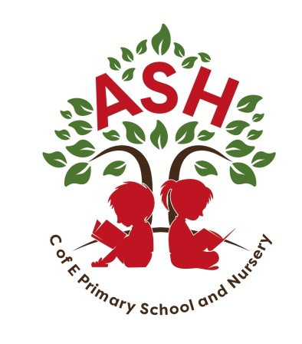

**Ash C E V C Primary School, Main Street, Ash, Martock**

**Somerset TA12 6NS Telephone: 01935 822674**

**Email: office@ashprimaryschool.co.uk**

**Headteacher: Jane Perry/Rebecca Bennett**

**15th September 2023**

**RE: WELCOME TO A NEW YEAR**

Dear Parents,

Firstly, we are pleased to welcome new and returning children into school after the summer holiday. We hope everyone had a good break despite the mixed weather during July and August.

As always, we are keen to ensure the school continues to make the most of its rural setting and to enable the overall environment both within the school building and its surrounding play areas as attractive and safe as we can for the children. As part of this commitment you will probably have seen that the playing field now has a climbing wall, the grass and shrubs have been cut and the small playground for children in early years has been resurfaced where it had become very worn. Internally we have had new carpet tiles fitted and had a general good clean throughout.

The other reason for the Board of Governors wishing to write to you at this time is to let you know that over recent months it has been considering joining a Multi Academy Trust (MAT) rather than continuing to be a Local Authority Maintained School.

The reasons for the doing this is:

* The Government has outlined plans for all schools to convert to academies by 2030. We would therefore like to be proactive in this process.
* We are keen to work more closely with other high achieving schools in the area and feel that they could support us on our school improvement journey.
* We are increasingly disappointed in the services and support that the school receives from the Local Authority

Over several months the Governing Board has conducted research into the various Academy Trusts within our region. After much deliberation we are pleased to let you know that the Board has voted unanimously in favour of applying to join the Preston Primary Academy Trust (PPAT).

We believe the benefits are of joining this Trust are:

* It focuses on primary education
* It is local to the Yeovil and surrounding villages
* It is passionate about creating an environment where all children have the opportunity to achieve the best they can
* It will enable the school to share best practice, teaching staff and facilities as needed to support the future development of staff and children
* The trust have church articles of association, which would ensure that we keep our distinctive Christian character.

**Next Steps**

Over the next few months there will be further communications and discussions with the Local Authority, the Trust, the Diocese and Regional Schools Commissioner. The latter has the final say as to whether our application to join the Trust can go ahead.

There will be further consultations with staff and communications with parents and children to ensure everyone is kept informed on the process and an opportunity to have their questions dealt with.

We have been advised that the process from start to finish is approximately 6-9 months and therefore anticipate that it may be sometime between June and September of next year before everything has been completed.

Attached are the answers to some of the most frequently asked questions which we hope will be helpful. However, if you have any further questions, please make arrangements to meet with the Co-Chairs and/or Headteacher.

Kind regards

Georgina Griffiths & Jane Billington (Co-Chairs of the Governing Board)

Jane Perry (Interim Headteacher)