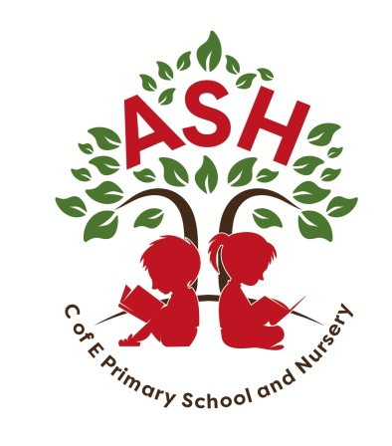

**Ash C E V C Primary School, Main Street, Ash, Martock**

**Somerset TA12 6NS Telephone: 01935 822674**

**Email: office@ashprimaryschool.co.uk**

**Headteacher: Rebecca Bennett**

**3rd November 2023**

Dear Parents

**Mock Trial – Tuesday 14th November**

We have been invited to take part in a Mock Trial at Perrott Hill School, which was a great success last year. As a class we have learnt all about the justice system and how a trial works from Mrs Mary Ellis who is a Justice of Peace. Though only some of the class are participating we are all going to watch the Mock Trial.

The children who are participating are required to wear formal, smart clothes. We have discussed this in class, and they have been asked to bring their outfit to school ASAP to be checked. Please do not go to any additional expense, they can use their black school uniform with a shirt or top.

We are leaving at 9.30 am and expect to return to school at 1.30. pm. We will eat lunch as soon as we are back, however please can you send your child to school with a sizeable, named snack as this will be a long morning for them. If you have a school lunch, please could you provide your child with a packed lunch on this day, or we can arrange to have your lunch saved for later. Please let the office know which option you are taking as we don’t want any hungry children.

We are all looking forward to participating in the Mock Trial and to having a successful morning in court!

If you have any concerns, please come and see me.

Kind regards

Mrs Louise Oaten