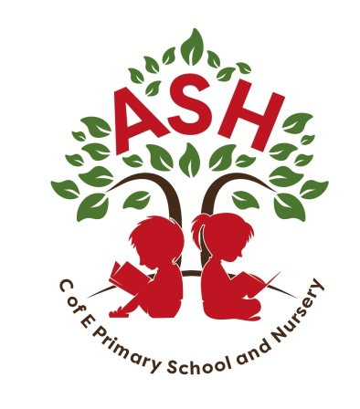
Ash C E V C Primary School, Main Street, Ash, Martock Somerset. TA12 6NS Telephone: 01935 822674 Email: office@ash.ppat365.org Headteacher: Melissa Gibbons
Monday 9th June 2025
Dear Ash Families,
As part of our Science and RSHE studies we will be teaching sex and relationship lessons. These lessons will take place Fridays in the weeks following the residential trip. The content for Year 6 is outlined below.
If you have any concerns and wish to discuss the content further, then please contact Mr Jones directly.
Sex Education
•Know about human sexuality and that it is expressed in different ways, understand what it means and have some words to describe it
•Appreciate different ways of loving and its importance to a range of relationships
•Understand about parenthood and, if they wish to marry, having the right to choose who they marry
•To explore the emotional and physical changes that occur during puberty
•To describe how and why the body changes during puberty in preparation for reproduction, to consider reproduction in the context of relationships
•To explore the process of conception and pregnancy and know some basic facts about both
•Answer each other’s questions about sex and relationships with confidence and know where to find support and advice
•Recognise that living things produce offspring of the same kind, but normally offspring vary and are not identical to their parents (Science curriculum)
NSPCC PANTS Campaign
As part of this work we will also be delivering the PANTS materials from the NSPCC, to teach children about how to keep safe from sexual abuse. More information can be found here https://www.nspcc.org.uk/keeping-children-safe/support-for-parents/pants-underwear-rule/
RSHE Guidance (DFE)
https://assets.publishing.service.gov.uk/government/uploads/system/uploads/attachment_data/file/907638/RSE_primary_schools_guide_for_parents.pdf
More information on the changes to the guidance on teaching RSHE is available here. Our policy is available for you to view here https://primarysite-prod-sorted.s3.amazonaws.com/ash-church-of-england-primary-school/UploadedDocument/b2f754652fb34ebb95c5d0379f4084bd/relationships-and-sex-education-policy.pdf
You have the right to withdraw your child from the non-statutory elements of sex education. Please contact us for the form if this is required.
Kindest regards
The Ash Team

