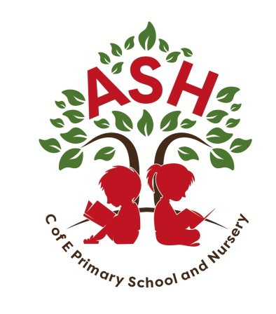**Ash C E V C Primary School, Main Street, Ash, Martock**

**Somerset TA12 6NS Telephone: 01935 822674**

**Email: office@ashprimaryschool.co.uk**

**Headteacher: Rebecca Bennett / Jane Perry**

27th June 2023

Dear Ash Families

At Ash Primary School we are committed to providing all pupils with a planned Personal, Social, Health, Education (PSHE) programme to enable them to acquire the knowledge, understanding, skills and strategies they need to develop an understanding of themselves, empathy and the ability to work with others to help pupils form and maintain good relationships, develop the essential skills for future employability and better enjoy and manage their lives. A full outline of our PSHE curriculum is attached to this letter.

Relationships Education and Health Education became statutory for all schools from September 2020. We have integrated the statutory requirements into our planned PSHE curriculum and other suporting curriculum areas.

The Government have produced some information leaflets for parents to explain what the curriculum consists of and is trying to achieve. To view these resources, please visit <https://www.gov/uk/government/publications/relationships-sex-and-health-education-guides-for-schools>

As part of the school’s PSHE programme, children learn about the emotional, social and physical aspects of growing up, healthy relationships and keeping themselves safe both on and offline.

As they progress through primary school, they will cover the following aspects of Relationships Education and Relationships and Sex Education:

* Pupils in all year groups from Reception to Year 6 are taught that some body parts are private and that their body belongs to them.
* Pupils in all year groups are taught about what physical contact is acceptable or unacceptable and that they have a right to say no both on and offline (consent). They are taught that they should tell an adult if they are worried. This is vital to support the work we do in keeping all pupils safe. To support us in delivering this message to the pupils, we use information from the NSPCC Underwear Rule campaign. You can find out more at http://www.nspcc.org.uk/
* In Year 5 pupils start to learn that their body and emotions will change as they get older and continue to build on learning about the key components of a healthy relationship and how to keep themselves safe both on and offline. This learning continues in Year 6
* In Year 5 pupils learn about all the external and internal genitalia and the ways in which children grow and develop in puberty both physically and emotionally.
* In Year 6 pupils further develop their understanding of the physical and emotional changes they go through at puberty and about human reproduction.
* As part of the statutory curriculum, in all year groups pupils learn about, diversity within and between families which includes lesbian, gay and bisexual couples. There is also work on gender identity which includes information about trans children and young people.

Teaching staff approach this aspect of the curriculum very sensitively and are aware of how it contributes to pupil’s development; supporting them to develop healthy relationships, keep themselves safe and having factually correct information and the skills to positively manage the physical and emotional changes that will happen as they grow into hopefully happy, confident and responsible teenagers.

Parents and carers also play a vital role in talking to their child(ren) about this important part of growing up and keeping themselves safe. To help you understand the type of questions children of different ages may ask and how to best respond to them further information can be obtained from the family planning association website – parent/carers section at <https://www.fpa.org.uk/help-mums-dads-and-carers>

Some aspects of this curriculum are delivered through the National Curriculum for Science and some through the PSHE/RSHE curriculum. Parents will be unable to withdraw children from the Relationships Education and Health Education.

At Ash Primary School, we have decided to teach Sex Education in Years 5 and 6, which parents will still be able to withdraw their children from. We will provide parents the opportunity to review the resources prior to teaching the lessons in order to help them to make an informed decision.

Although parents/carers have the right to request to withdraw their child from any or all of sex education as part of Relationships Education, it is our aim to encourage parents to see the value of RSE learning and its contribution to keeping children safe, developing their emotional, social and physical wellbeing and for promoting equality and social justice.

Should a parent decide that they do not wish their child to take part in any of the Year 5 or 6 sex education lessons, we would ask that they first speak to the headteacher to discuss their concerns. The headteacher will discuss the request with the parent/carer to fully understand and address any concerns/objections to the content of the curriculum. If parents/carers do decide to withdraw their child, they should inform the headteacher in writing and the school will keep a record of this.

If you would like to see the school’s Relationships and Sex Education Policy, along with the learning objectives for each year group please visit the school website. You can find the details by going to Key Information and then Policies.

If you have any further questions about this aspect of the curriculum or wish to see any of the teaching resources, please contact your child’s teacher.

**The teaching will start tomorrow Friday 28th June**

Yours sincerely

Mrs Jane Perry

Headteacher