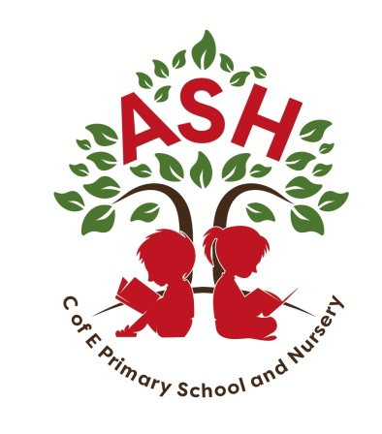
Ash C E V C Primary School, Main Street, Ash, Martock
Somerset TA12 6NS Telephone: 01935 822674
Email: office@ash.ppat365.org

Headteacher: Melissa Gibbons

Tuesday 22nd April

Dear Parent/Carers,

YEAR 3, 4, 5 and 6 We the Curious Science Museum Trip

We are planning a visit to We the Curious in Bristol on Friday 16th May 2025. The aim of the visit is for the children to experience the wonder of science through exploration and hands on learning. Each class has their own workshop that they will attend, followed by an amazing Planetarium show designed specifically for their age.
The party leaders will be Mrs Gibbons, Miss Leslie, Mr Jones and Mr Sampson – Barnes. We will also be accompanied by a selection of parent/governor helpers.
Our transport will be provided by Vickery Coaches. Our aim is to leave school at precisely 9am and return to school at the later time of approximately 4.00 - 4.30pm. A text message will be sent to confirm the time, as this will be determined by traffic. Please could all children bring a packed lunch in a box, with a water bottle. No bags are allowed in the museum, so your child will need to be able to carry their own lunchbox and drink.

All school meals for Yrs 3 - 6 will be packed lunches – If your child is having school meals, please choose the packed lunch option for this day.

Financial Arrangements
- Parents are asked to make a voluntary contribution of £19 this is to cover the cost of the coach and entrance to the museum. Payment will be through Parent Pay. Huge thank you to the PTA, who have contributed a subsidy of £700
- Payment should be received by Friday 9th May 2025. (Museum requires payment in advance)

Insurance
The school only provides cover against proven or agreed negligence by the Authority and its employees. Parents may wish to make their own insurance arrangements for personal accident cover for their children.
Medical Needs
If your child has medical needs affecting him/her during the visit please inform the party leaders, in person or in writing, providing details.
Should there be any enquiries regarding the day please contact the school and we will do our best to help.

Kindest Regards

Hannah Leslie

