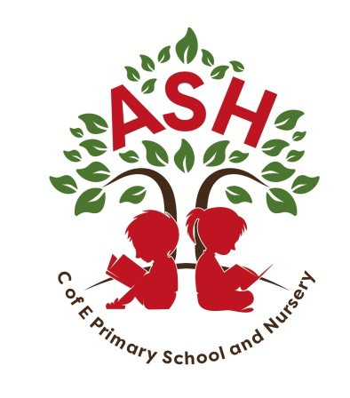
Ash C E V C Primary School, Main Street, Ash, Martock
Somerset TA12 6NS Telephone: 01935 822674
Email: office@ash.ppat365.org

Headteacher: Melissa Gibbons

Monday 9th September

Dear Parent/Carers,

YEAR 5 AND 6 LONDON APOLLO VICTORIA – WICKED

We are planning an exciting visit to London Apollo Victoria Theatre on Wednesday 8th January 2025 The aim of the visit is for the children to experience the magic of professional, musical theatre.
The party leaders will be Mrs Gibbons, Mrs Oaten, Mr Jones and Mrs Frampton.

Our transport will be provided by Vickery Coaches. Our aim is to leave school at precisely 9.00am and return to school at the much later time of approximately 10.00pm. We will be stopping for a comfort break, both on the way there and the return journey at Fleet Services. Please could all children bring a packed lunch for the journey there and a packed tea for the return journey, along with extra food / snacks and plenty of drink.

A phone chain system will be established nearer the time of the visit, in order to notify of specific time arrival on return.

Our wonderful PTA have kindly subsidised this trip, significantly lowering the cost. However, I do still fully apologise for this practically coinciding with the residential payment.

Financial Arrangements
- Parents are asked to make a voluntary contribution of £30.00 this will cover the cost of the coach and performance. Payment will be through Parent Pay
- Payment should be received by Friday 30th September 2024 at the very latest. (Theatre requires payment in advance)

Insurance
The School only provides cover against proven or agreed negligence by the Authority and its employees. Parents may wish to make their own insurance arrangements for personal accident cover for their children.
Medical Needs
If your child has medical needs affecting him/her during the visit please inform the party leaders, in person or in writing, providing details.
Should there be any enquiries regarding the day please contact the school and we will do our best to help.

Kindest Regards

Melissa Gibbons

