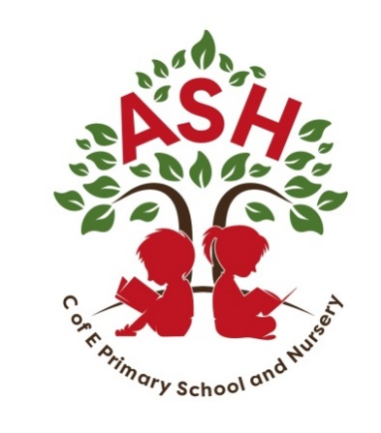
Ash C E V C Primary School, Main Street, Ash, Martock
Somerset TA12 6NS Telephone: 01935 822674
Email: office@ash.ppat365.org

Headteacher: Melissa Gibbons

6th September 2024

YEAR 5 and 6 - RESIDENTIAL TRIP TO YHA Okehampton
Departure: Monday 9th June 2025 9.30am
Return: Wednesday 11th June 2025 3.30pm

Dear Parents /Carers,

For the past few years, we have very successfully taken groups of children away on residentials, this coming year we have decided to take the children to Okehampton. We will be staying at the YHA Okehampton Youth Hostel.

There are various activities the children will be able to participate in whilst there, which might include:

• abseiling • archery • canoeing • climbing • high ropes • guided walk • map skills and navigation • raft building • shelter building and fire lighting • team challenges • gorge scrambling • cycling

Staff from Ash School staying with the children will include Mr Jones, Mrs Oaten and Mrs Frampton.

If you would like to have a look at the centre, please click on the link below

https://www.yha.org.uk/activity-centres/okehampton

If you would like your son/daughter to take part in this residential, please return the form below. We require a deposit of £50.00 to be paid by Friday 27th September 2024 at the latest. The payment item will be set up on ParentPay.

Further information including kit lists, medical forms etc will be sent out nearer the time.

Yours sincerely

Mrs Oaten and Mr Jones

Please return the slip to the school office by Friday 13th September 2024

…………………………………………………………………..
RESIDENTIAL TRIP TO OKEHAMPTON
Monday 9th June 2025 AM – Wednesday 11th June 2025 PM

Child’s name ________________________________________ is interested in the YHA Okehampton Residential trip.

I have read, fully understand and am satisfied with the details of the above activity and agree to my child’s participation.

Signed _______________________________________________ Parent/Carer

