Lavender Country Kitchen Allergen Matrix – School Puddings – Reviewed September 2024

Dishes | 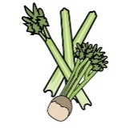 | 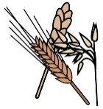 | 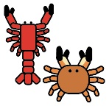 | 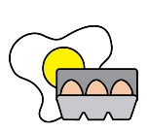 |  | 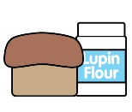 |  |  | 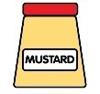 | 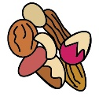 | 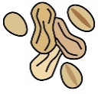 | 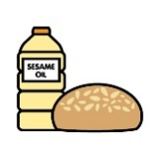 |  | 
 | Celery | Cereals containing gluten* | Crustaceans | Eggs | Fish | Lupin | Milk | Mollusc | Mustard | Nuts† | Peanuts | Sesame seeds | Soya | Sulphur Dioxide
Fruit Yogurt |  |  |  |  |  |  | ✓
Strawberry Angel Delight |  |  |  | ✓ |  |  | ✓
Waffle & Greek Yogurt |  | ✓ |  | ✓ |  |  | ✓ |  |  |  |  |  | ✓
Jelly
Vanilla Ice Cream |  |  |  |  |  |  | ✓
Chocolate Sponge |  | ✓ |  | ✓ |  |  | ✓ |  |  |  |  |  | ✓
Chocolate Custard |  |  |  |  |  |  | ✓
Blueberry Muffin |  | ✓ |  | ✓ |  |  | ✓
Custard |  |  |  |  |  |  | ✓
Mango & Orange Smoothie
Peaches
Dishes
 | Celery | Cereals containing gluten* | Crustaceans | Eggs | Fish | Lupin | Milk | Mollusc | Mustard | Nuts† | Peanuts | Sesame seeds | Soya | Sulphur Dioxide
Banana Loaf |  | ✓ |  | ✓ |  |  | ✓
Vanilla Cheesecake & Coulis |  | ✓ |  |  |  |  | ✓
Victoria Sponge |  | ✓ |  | ✓ |  |  | ✓ |  |  |  |  |  | ✓
Strawberry Mousse |  |  |  |  |  |  | ✓
Jam Sponge |  | ✓ |  | ✓ |  |  | ✓
Fruit Salad
Squirty Cream |  |  |  |  |  |  | ✓
Apple Crumble |  | ✓ |  |  |  |  | ✓
Oat and Raisin Cookie |  | ✓ |  |  |  |  | ✓ |  |  |  |  |  | ✓
Cocoa Crispy Cake |  |  |  |  |  |  | ✓ |  |  |  |  |  | ✓

Review date: |  | Reviewed by: |  |  |  |  | You can find this template, including more information at www.food.gov.uk/allergy-guidance

Dishes |  |  |  |  |  |  |  |  | 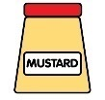
 | Celery | Cereals containing gluten* | Crustaceans | Eggs | Fish | Lupin | Milk | Mollusc | Mustard | Nuts† | Peanuts | Sesame seeds | Soya | Sulphur Dioxide
Artic Roll |  | ✓ |  | ✓ |  |  | ✓ |  |  |  |  |  | ✓
Apple Cake |  | ✓ |  | ✓ |  |  | ✓
Peach & Raspberry Cobbler |  | ✓ |  | ✓ |  |  | ✓
Iced Shortbread |  | ✓ |  |  |  |  | ✓
Apple Oaty Slice |  | ✓ |  |  |  |  | ✓
Strawberry Iced Smoothie
Flapjack |  | ✓ |  |  |  |  | ✓
Swiss Roll |  | ✓ |  | ✓ |  |  | ✓
Jam Doughnut |  | ✓ |  |  |  |  | ✓ |  |  |  |  |  | ✓
Strawberry Yogurt & Granola |  | ✓ |  |  |  |  | ✓

Dishes |  |  |  |  |  |  |  |  | 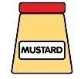
 | Celery | Cereals containing gluten* | Crustaceans | Eggs | Fish | Lupin | Milk | Mollusc | Mustard | Nuts† | Peanuts | Sesame seeds | Soya | Sulphur Dioxide
Neapolitan Loaf Cake |  | ✓ |  | ✓ |  |  | ✓ |  |  |  |  |  | ✓
Toffee Cake |  | ✓ |  | ✓ |  |  | ✓
Pancakes and Compote |  | ✓ |  | ✓ |  |  | ✓
Apricot Oaty Slice |  | ✓ |  |  |  |  | ✓
Cookie |  | ✓ |  | ✓ |  |  | ✓
Angel Cake |  | ✓ |  | ✓ |  |  | ✓
Shortbread |  | ✓ |  |  |  |  | ✓
Iced Sponge |  | ✓ |  | ✓ |  |  | ✓
Choc Swiss Roll |  | ✓ |  | ✓ |  |  | ✓ |  |  |  |  |  | ✓
Chocolate Marble Cake |  | ✓ |  | ✓ |  |  | ✓ |  |  |  |  |  | ✓

