 | Autumn 1 |  | Autumn 2
Reading objectives | Apply growing knowledge of root words, prefixes and suffixes.  Read further exception words.  Checking a text makes sense by discussing and explaining the meaning of words in context.  Drawing inference. Feelings, motives and actions and justify this with evidence  Making predictions after knowing the details stated. |  | Retrieve and record information from non-fiction.  Listen and discuss a wide range of poetry and non-fiction  Use dictionaries to check the meanings of words  Increasing familiarity with a wide range of books myths and legends.  Listen and discuss a wide range of poetry*
Core texts | 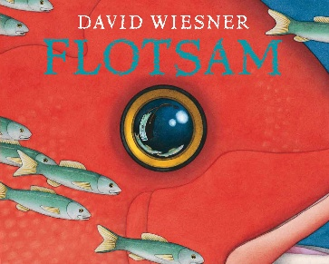  Flotsam  S. Wiesner  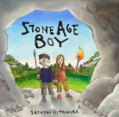  Stone Age Boy  S. Kitamura  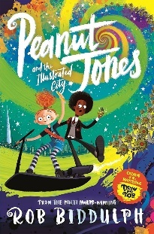  Guided reading  Peanut Jones  R. Biddulph |  | 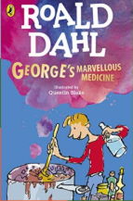  George’s Marvellous Medicine  R.Dahl  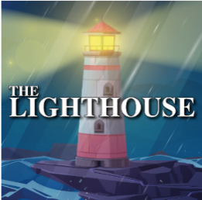  The light house  Short film  Guided reading  Peanut Jones  R. Biddulph
Writing | Flotsam  Prediction  Questions  Narrative  Stone age boy  Diary  Information  narrative |  | George’s marvellous medicine  Lists  Instructions  Recipe  Formal writing  Character description  The lighthouse  Expanded noun phrases  Fronted adverbials  Openers  Possessive apostrophes  Emotions  Diary/letter  Formal and informal
Grammar & Punctuation | - Singular and plural nouns  - Pronouns  - Compound words  - Adverbs to express time and cause  - Suffixes – ly |  | - Possessive nouns  - Fronted adverbials  - Prepositions time and cause  - Plural and possessives  - Commas
Spelling | Year 3  - /ai/ sound spelt ei  - /ai/ sounds spelt ey  - /ai/ sounds spelt ai  - /ur/ spelt ear  - Homophones and near homophones | Year 4  - Aw  - Prefix in-  - Prefix im-  - Prefix il-  - Homophones and near homophones  - /Shun/ Words that end in ‘sion’ | Year 3  - Adverbs with ly  - Statutory spellings | Year 4  - Words with /shuhn/  - words with /ough/  - Statutory spellings
Handwriting | To increase the legibility, consistency and quality of their handwriting focusing on letter formation, cursive joins and correct size.
Home | - Read 5 times a week and record Reading Records.  - Learn spelling rules, ‘remember how to’ and tricky words for a weekly spelling test and application in their writing.  - Spelling bee weekly assignments

