 | Autumn A | Autumn B |  | Spring A | Spring B |  | Summer A |  | Summer B
Maths | 
English | 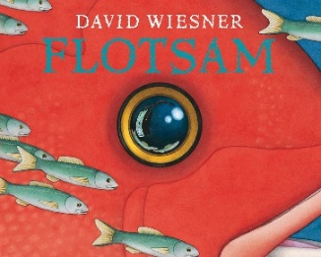  Prediction  Questions  Narrative  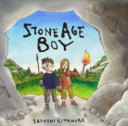  Diary  Information  narrative  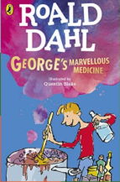  Lists  Instructions  Recipe  Formal writing  Character description |  |  | 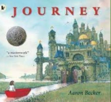  Narrative  Dilogue  Action  Setting  Sequal  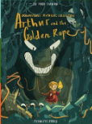  Narrative  Character  Diary  Persuasive letter  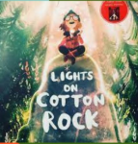  Narrative  Comic strip  Newspaper  Diary  Poetry  Non-chrological reprot |  |  | 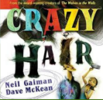    Diary entry  Non-cronological reports  Narrative  Narrative  Poetry  Rhyming patterns  Direct speech  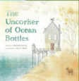  Job advertisment  Job application  Letter
Guided Reading | 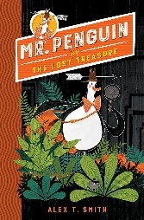 |  |  | 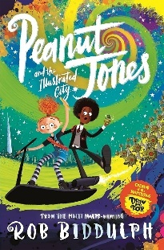 |  |  | 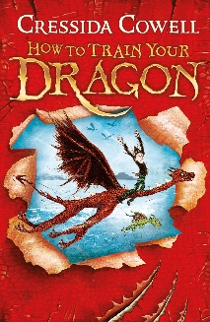
Science  Cornerstones | Year 3  Animals, including humans  - identify that animals, including humans, need the right types and amount of nutrition, and that they cannot make their own food; they get nutrition from what they eat  - identify that humans and some other animals have skeletons and muscles for support, protection and movement |  | Year 4  .  Animals, including humans  - describe the simple functions of the basic parts of the digestive system in humans  - identify the different types of teeth in humans and their simple functions  - construct and interpret a variety of food chains, identifying producers, predators and prey  Sound  - identify how sounds are made, associating some of them with something vibrating  - recognise that vibrations from sounds travel through a medium to the ear  - find patterns between the pitch of a sound and features of the object that produced it  - find patterns between the volume of a sound and the strength of the vibrations that produced it  - recognise that sounds get fainter as the distance from the sound source increases | Year 3  Rocks  - compare and group together different kinds of rocks on the basis of their appearance and simple physical properties  - describe in simple terms how fossils are formed when things that have lived are trapped within rock  - recognise that soils are made from rocks and organic matter  Forces and magnets  - compare how things move on different surfaces  - notice that some forces need contact between 2 objects, but magnetic forces can act at a distance  - observe how magnets attract or repel each other and attract some materials and not others  - compare and group together a variety of everyday materials on the basis of whether they are attracted to a magnet, and identify some magnetic materials  - describe magnets as having 2 poles  - predict whether 2 magnets will attract or repel each other, depending on which poles are facing |  | Year 4  Living things and their habitats  - recognise that living things can be grouped in a variety of ways  - explore and use classification keys to help group, identify and name a variety of living things in their local and wider environment  - recognise that environments can change and that this can sometimes pose dangers to living things  States of matter  - compare and group materials together, according to whether they are solids, liquids or gases  - observe that some materials change state when they are heated or cooled, and measure or research the temperature at which this happens in degrees Celsius (°C)  - identify the part played by evaporation and condensation in the water cycle and associate the rate of evaporation with temperature | Year 3  Light  - recognise that they need light in order to see things and that dark is the absence of light  - notice that light is reflected from surfaces  - recognise that light from the sun can be dangerous and that there are ways to protect their eyes  - recognise that shadows are formed when the light from a light source is blocked by an opaque object  - find patterns in the way that the size of shadows change  Plants  - identify and describe the functions of different parts of flowering plants: roots, stem/trunk, leaves and flowers  - explore the requirements of plants for life and growth (air, light, water, nutrients from soil, and room to grow) and how they vary from plant to plant  - investigate the way in which water is transported within plants  - explore the part that flowers play in the life cycle of flowering plants, including pollination, seed formation and seed dispersal | Year 4  Electricity  - identify common appliances that run on electricity  - construct a simple series electrical circuit, identifying and naming its basic parts, including cells, wires, bulbs, switches and buzzers  - identify whether or not a lamp will light in a simple series circuit, based on whether or not the lamp is part of a complete loop with a battery  - recognise that a switch opens and closes a circuit and associate this with whether or not a lamp lights in a simple series circuit  - recognise some common conductors and insulators, and associate metals with being good conductors
History  Cornerstones | Stone age to the Iron age  changes in Britain from the Stone Age to the Iron Age |  |  |  |  |  | Romans  - the Roman Empire and its impact on Britain
Geography  Cornerstones | One planet our world  - locate the world’s countries, using maps to focus on Europe (including the location of Russia) and North and South America, concentrating on their environmental regions, key physical and human characteristics, countries, and major cities  - name and locate counties and cities of the United Kingdom, geographical regions and their identifying human and physical characteristics, key topographical features (including hills, mountains, coasts and rivers), and land-use patterns; and understand how some of these aspects have changed over time  - identify the position and significance of latitude, longitude, Equator, Northern Hemisphere, Southern Hemisphere, the Tropics of Cancer and Capricorn, Arctic and Antarctic Circle, the Prime/Greenwich Meridian and time zones (including day and night) |  |  | Rocks, relics and rumbles  describe and understand key aspects of:  - physical geography, including: climate zones, biomes and vegetation belts, rivers, mountains, volcanoes and earthquakes, and the water cycle  - human geography, including: types of settlement and land use, economic activity including trade links, and the distribution of natural resources including energy, food, minerals and water |  |  | .
Computing  (NCCE) | Computing systems and networks |  | Creating media | Programming A |  | Data and information | Creating media | Programming B
Art  Cornerstones | Neolithic art |  |  | Artist profile |  |  | Romann Mosaic
DT  Cornerstones | Making it move  - use research and develop design criteria to inform the design of innovative, functional, appealing products that are fit for purpose, aimed at particular individuals or groups  - generate, develop, model and communicate their ideas through discussion, annotated sketches, cross-sectional and exploded diagrams, prototypes, pattern pieces and computer-aided design  Make  - select from and use a wider range of tools and equipment to perform practical tasks [for example, cutting, shaping, joining and finishing], accurately  - select from and use a wider range of materials and components, including construction materials, textiles and ingredients, according to their functional properties and aesthetic qualities  Evaluate  - investigate and analyse a range of existing products  - evaluate their ideas and products against their own design criteria and consider the views of others to improve their work  - understand how key events and individuals in design and technology have helped shape the world  Technical knowledge  - apply their understanding of how to strengthen, stiffen and reinforce more complex structures  - understand and use mechanical systems in their products [for example, gears, pulleys, cams, levers and linkages]  - understand and use electrical systems in their products [for example, series circuits incorporating switches, bulbs, buzzers and motors]  - apply their understanding of computing to program, monitor and control their products. |  |  | Cook well, Eatwell  - use research and develop design criteria to inform the design of innovative, functional, appealing products that are fit for purpose, aimed at particular individuals or groups  - generate, develop, model and communicate their ideas through discussion, annotated sketches, cross-sectional and exploded diagrams, prototypes, pattern pieces and computer-aided design  Make  - select from and use a wider range of tools and equipment to perform practical tasks [for example, cutting, shaping, joining and finishing], accurately  - select from and use a wider range of materials and components, including construction materials, textiles and ingredients, according to their functional properties and aesthetic qualities  Evaluate  - investigate and analyse a range of existing products  - evaluate their ideas and products against their own design criteria and consider the views of others to improve their work  - understand how key events and individuals in design and technology have helped shape the world  Technical knowledge  - apply their understanding of how to strengthen, stiffen and reinforce more complex structures  - understand and use mechanical systems in their products [for example, gears, pulleys, cams, levers and linkages]  - understand and use electrical systems in their products [for example, series circuits incorporating switches, bulbs, buzzers and motors]  apply their understanding of computing to program, monitor and control their products. |  |  | Greenhouse  - use research and develop design criteria to inform the design of innovative, functional, appealing products that are fit for purpose, aimed at particular individuals or groups  - generate, develop, model and communicate their ideas through discussion, annotated sketches, cross-sectional and exploded diagrams, prototypes, pattern pieces and computer-aided design  Make  - select from and use a wider range of tools and equipment to perform practical tasks [for example, cutting, shaping, joining and finishing], accurately  - select from and use a wider range of materials and components, including construction materials, textiles and ingredients, according to their functional properties and aesthetic qualities  Evaluate  - investigate and analyse a range of existing products  - evaluate their ideas and products against their own design criteria and consider the views of others to improve their work  - understand how key events and individuals in design and technology have helped shape the world  Technical knowledge  - apply their understanding of how to strengthen, stiffen and reinforce more complex structures  - understand and use mechanical systems in their products [for example, gears, pulleys, cams, levers and linkages]  - understand and use electrical systems in their products [for example, series circuits incorporating switches, bulbs, buzzers and motors]  apply their understanding of computing to program, monitor and control their products.
Music  Charanga  Sing Up | A shining performance  Read and play G, A and B (doh, re, me) on a musical instrument.  Use creative ideas inspired by different stimuli to improve a performance. |  |  | Sing and move  Sing songs with attention to expression and dynamics, following the conductor's cues.  Perform actions with accuracy and confidence. |  |  | Percussion power  Compose song accompaniments on untuned percussion using known rhythms and note values.  Introduce and understand the differences between crotchets and paired quavers.
PE  Twinkl | Invasion Games |  | Gymnastics | Circuit training |  | Dance | Striking and Fielding | Athletics
PSHE  Twinkl | Health and wellbeing |  | Health and wellbeing | Relationships |  | Relationships | Living in the wider world | Living in the wider world
RE  Cornerstones | Hinduism  Ganesh Chaturthi |  | Sikhism  Guru Nanak  Gurpurab | Christianity  Lent |  | Judaism  Shavuot | Buddhism  Vesak | Islam  Hajj

