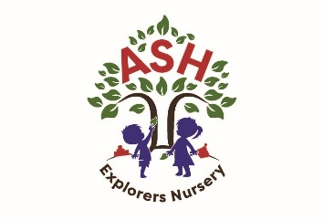
Ash CE VC Primary School & Nursery
Main Street, Ash, Somerset, TA12 6NS
( 01935 822674
office@ash.ppat365.org
www.ashprimaryschool.co.uk

A Few Little Reminders

Each day your child will need:

• A named water bottles

• Bag – rucksack style with spare clothes

• A named practical coat

• Nappies/wipes/comforter

Items to bring at the beginning of each term and leave at nursery:

• Children will need a PE kit (gray shorts, white PE t-shirt, slip on or Velcro black daps). This will be sent home each half term to be washed.

• Named wellington boots.

• Sun Protection Cream (warmer months)

• Sun hat (warmer months)

Please ensure every item your child brings into nursery is clearly labelled with their name.

If anything is lost, please let us know as soon as possible.

We encourage children to be independent when they are in school. You can help your child get nursery ready by encouraging them to dress themselves, put on shoes, and do their coats up by themselves.

If you have any questions, please do not hesitate to ask.

Thank you for your support.

Isabelle Harrington Nursery Lead

