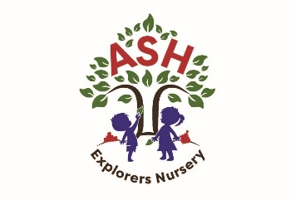
Ash CE VC Primary School & Nursery
Main Street, Ash, Somerset, TA12 6NS
( 01935 822674
office@ash.ppat365.org
www.ashprimaryschool.co.uk

Dear Parent / Guardian,

The School Food Plan – Free Milk for Your Child In conjunction with the Department of Education’s School Food Plan, our school is providing a free 189ml portion of low-fat milk to all children in the Nursery.

Should you wish for your child to enjoy a daily serving of milk at nursery, please return the confirmation slip below to the school office.

Should you have any questions regarding the information outlined in this letter, please do not hesitate to contact the school office.

Kind regards
Mrs M Gibbons
Head Teacher

I would like to request free milk for my child, and give permission for the following details to be passed onto our milk supplier:

Child’s name:

Child’s Date of Birth:

Parent/Carer Name:

Parent/Carer signature:

Date: I do not wish my child to receive free milk:

Child’s Name: Parent/Carer Name:

Parent/Carer Signature:

Date

