YEAR 1 | Autumn 1  (Toys- Then and Now) | Autumn 2  (Toys- Then and Now)
 | - Retell traditional tales discussing character.  - Read common exception words.  - Make predictions based on reading so far. Read accurately by blending. | - Read common exception words.  - Make predictions based on reading so far.  - Read accurately by blending.  - Read aloud accurately and fluently.  - Recognise and join in with predictable phrases and rhyming patterns.
Core Texts | 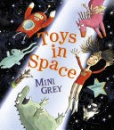  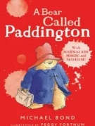  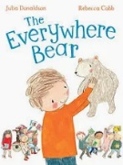 | 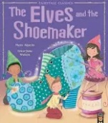  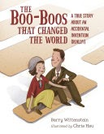  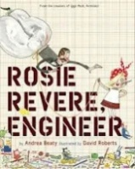
Writing | Labelling  Lists  Instructions  Narrative  Descriptions | Descriptions  Narrative  Fact file  Letters  Poetry
Vocabulary, Grammar and Punctuation | Use spaces between words. Use capital letters and full stops.  Use present and past tense correctly. | Use spaces between words. Use capital letters and full stops.  Use simple adjectives.  Use a range of punctuation – question marks.
Handwriting | - To sit correctly at a table, holding a pencil comfortably and correctly.  - To form lower case letters of the correct size, starting and finishing in the correct place.  - To form digits 0-9.  - To form capital letters.  - Long ladder family  - Part of one-armed robot family
Home | - Read at least three times a week.  - Learn weekly spellings

