YEAR 2 | Autumn 1  (Toys- Then and Now) | Autumn 2  (Toys- Then and Now)
- Continue to apply phonic knowledge and skills.
- Read accurately by blending sounds in words.
- Read accurately words of two or more syllables.
- Improve fluency and confidence.
- Read common exception words.
- Read words containing common suffixes.
Answer questions about a text.
Core Texts | 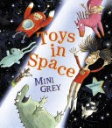  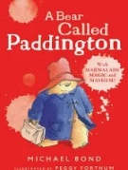  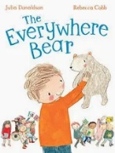 | 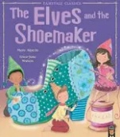  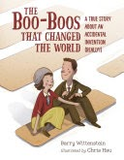  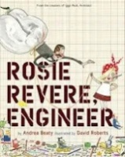
Writing | Labelling  Lists  Instructions  Narrative  Descriptions | Descriptions  Narrative  Fact file  Letters  Poetry
Vocabulary, Grammar and Punctuation | Use and understand noun phrases.  Use capital letters, full stops, question marks to demarcate sentences.  Use commas for lists. Explore sentence forms – exclamation, statement, question, command.  Use some subordinating and co coordinating conjunctions.  Use suffixes – ed, ing, ly.
Handwriting | - Form lower case letters of the correct size relative to one another  - Write capital letters and digits of the correct size, orientation and relationship to one another  - Use spacing between words that reflect size of letters  - Begin to use some of the diagonal and horizontal strokes needed to join.
Home | - Read at least three times a week.  - Learn weekly spellings

