 | Autumn A | Autumn B |  | Spring A | Spring B |  | Summer A |  | Summer B
Topic | Toys – Then and Now |  |  | City Vs. Country |  |  | Wonderful World
Maths | 
English | 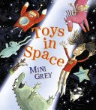  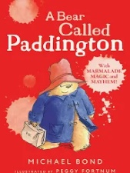  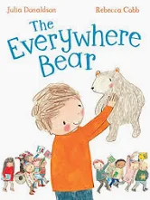  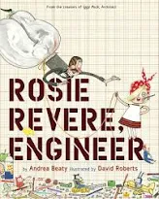  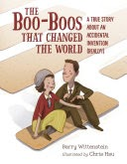  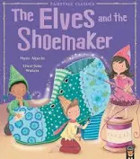 |  |  | 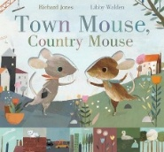  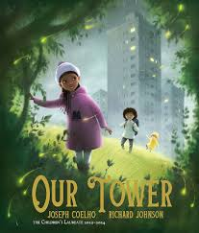  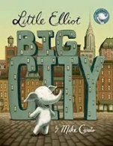  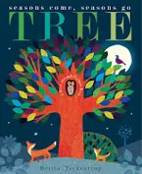  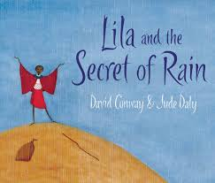  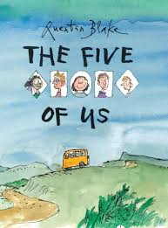 |  |  | 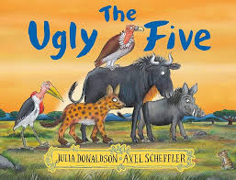  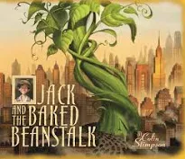  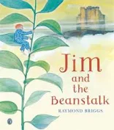  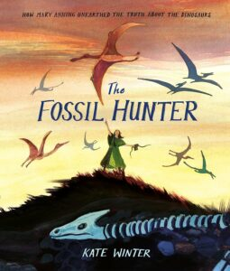  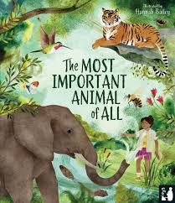  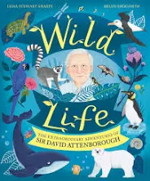
Science  Cornerstones | Year 1  Materials:  - Distinguish between an object and the material from which it is made ▪ identify and name a variety of everyday materials, including wood, plastic, glass, metal, water, and rock  - Describe the simple physical properties of a variety of everyday materials  - Compare and group together a variety of everyday materials on the basis of their simple physical properties. |  | Year 2  Materials:  - Identify and compare the suitability of a variety of everyday materials, including wood, metal, plastic, glass, brick, rock, paper and cardboard for particular uses.  - Find out how the shapes of solid objects made from some materials can be changed by squashing, bending, twisting and stretching. | Year 1  Seasonal Changes:  - Observe changes across the four seasons  - Observe and describe weather associated with the seasons and how day length varies. |  | Year 2  Living things and their habitats:  - Explore and compare the differences between things that are living, dead, and things that have never been alive.  - Identify that most living things live in habitats to which they are suited and describe how different habitats provide for the basic needs of different kinds of animals and plants, and how they depend on each other  - Identify and name a variety of plants and animals in their habitats, including microhabitats describe how animals obtain their food from plants and other animals, using the idea of a simple food chain, and identify and name different sources of food. | Year 1  Plants:  - Identify and name a variety of common wild and garden plants, including deciduous and evergreen trees  - Identify and describe the basic structure of a variety of common flowering plants, including trees.  Animals:  - Identify and name a variety of common animals including fish, amphibians, reptiles, birds and mammals identify and name a variety of common animals that are carnivores, herbivores and omnivores  - Describe and compare the structure of a variety of common animals (fish, amphibians, reptiles, birds and mammals, including pets)  - Identify, name, draw and label the basic parts of the human body and say which part of the body is associated with each sense. | Year 2  Plants:  - Observe and describe how seeds and bulbs grow into mature plants  - Find out and describe how plants need water, light and a suitable temperature to grow and stay healthy.  Animals:  - Notice that animals, including humans, have offspring which grow into adults.  - Find out about and describe the basic needs of animals, including humans, for survival (water, food and air)  - Describe the importance for humans of exercise, eating the right amounts of different types of food, and hygiene.
History  Cornerstones | Toys and inventions  •Changes within living memory. Where appropriate, these should be used to reveal aspects of change in national life.  •Events beyond living memory (first Aeroplane flight).  •Lives of significant individuals (inventor) |  |  |  |  |  | Wonderful World  •The lives of significant individuals in the past who have contributed to national and international achievements. Some should be used to compare aspects of life in different periods.  •Significant historical events, people and places in their own locality
Geography  Cornerstones |  |  |  | City Vs Country  • Identify seasonal and daily weather patterns in the United Kingdom and the location of hot and cold areas of the world in relation to the Equator and the North and South Poles  •Use basic geographical vocabulary to refer to:  •Key physical features, including: beach, cliff, coast, forest, hill, mountain, sea, ocean, river, soil, valley, vegetation, season and weather  •Key human features, including: city, town, village, factory, farm, house, office, port, harbour and shop.  •Name, locate and identify characteristics of the four countries and capital cities of the  United Kingdom and its surrounding seas.  •Understand geographical similarities and differences through studying the human and physical geography of a small area of the United Kingdom, and of a small area in a contrasting non-European country.  •Use aerial photographs and plan perspectives to recognise landmarks and basic human and physical features; devise a simple map; and use and construct basic symbols in a key.  •Use world maps, atlases and globes to identify the United Kingdom and its countries,  as well as the countries, continents and oceans studied at this key stage. |  |  | Our Wonderful World  •Name and locate the world’s seven continents and five oceans.  •Use aerial photographs and plan perspectives to recognise landmarks and basic human and physical features; devise a simple map; and use and construct basic symbols in a key.  •Use world maps, atlases and globes to identify the United Kingdom and its countries,  as well as the countries, continents and oceans studied at this key stage.
Computing  (NCCE) | Computing systems and networks – Technology around us |  | Creating media – Digital painting | Programming A – Moving a robot |  | Data and information – Grouping data | Creating media – Digital writing | Programming B - Programming animations
Art  Cornerstones | Funny Faces and Fabulous Features  Paint and collage |  |  | Rain and sunrays  Motifs; Line and shape; Texture; Collagraphy. |  |  | Street View  Mural makers
DT  Cornerstones | Shade and Shelter  Naming everyday materials; Properties and uses of materials |  |  | TAXI!  Mechanisms – wheels, axles and chassis |  |  | Chop, Slice and Mash  Sources of food; Food preparation techniques; Hygiene rules; Designing and making salads and sandwiches
Music  Charanga  Sing Up | My Musical Heartbeat  - Identify and mark pulse (beat)  - Improvise using CDE.  Dance, Sing, Play  - Clap simple rhythms  Respond to high and low pitches. |  |  | Exploring Sounds  - Create simple melodies using pitch, rhythm and dynamics.  Learning to Listen  Use eyes, ears and feel sounds in order to listen and describe to music. |  |  | Having Fun with Improvisation  - Learn to improvise, understanding it is an activity anyone can do.  Let’s Perform Together  Performance (singing and playing) is an important part of music, share with others what has been learnt and practised.
PE  Twinkl | Invasion Games |  | Gymnastics | Circuit training |  | Dance | Striking and Fielding | Athletics
PSHE  Twinkl | Be Yourself |  | Digital Wellbeing | Growing up |  | It’s my body | One World | Safety first
RE  Cornerstones | Christianity  Harvest |  | Hinduism  Diwali | Judaism  Purim |  | Islam  Milad un Nabi | Sikhism  Naam Karan | Buddhism  Esala Perahera

