Year 5 Venus Class Annual Curriculum Overview (2025–26)
 | Autumn A | Autumn B | Spring A | Spring B | Summer A | Summer B
Topic | Groundbreaking Greeks |  | Frozen Kingdom |  | Maafa
Maths | 
English | Narrative  Diary Entry  Letters  Instructions  Newspaper report  Non-Fiction Report  Dialogue  Poetry  Recount |  | Narrative  Comparison  Discursive  Newspaper report  Non-Fiction Report  Dialogue  Diary Entry  Persuasive  Recount |  | Narrative  Comparison  Discursive  Instructions  Non-Fiction Report  Dialogue  Poetry  Persuasive  Recount
Text | 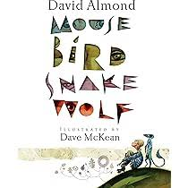  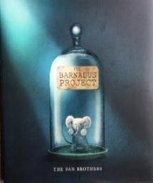  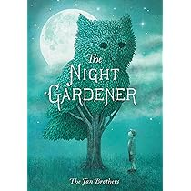  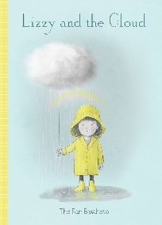  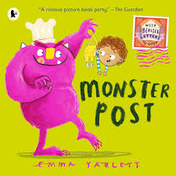 |  | 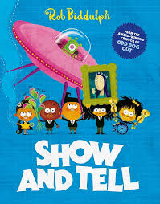  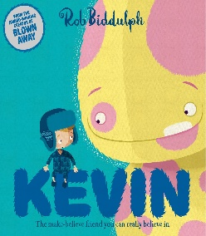  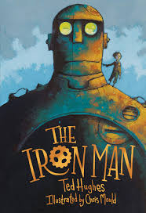  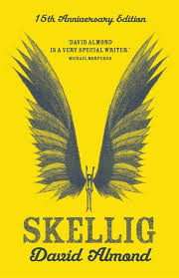 |  | 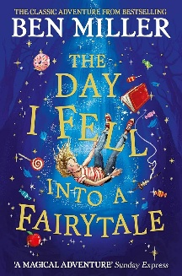  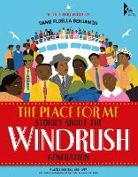
Guided  Reading | 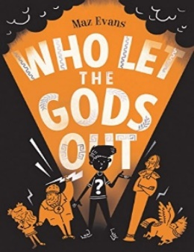 |  | 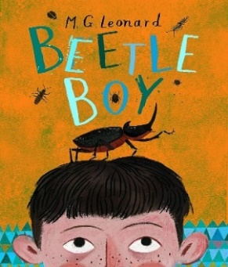 |  | 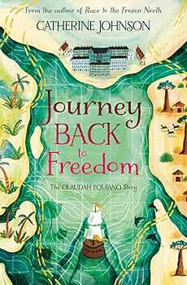
Science –  Cornerstones | EARTH AND SPACE  - describe the movement of the Earth and other planets relative to the sun in the solar system.  - describe the movement of the moon relative to the Earth.  - describe the sun, Earth and moon as approximately spherical bodies.  - use the idea of the Earth’s rotation to explain day and night and the apparent movement of the sun across the sky  FORCES AND MECHANISMS  - explain that unsupported objects fall towards the Earth because of the force of gravity acting between the Earth and the falling object.  - identify the effects of air resistance, water resistance and friction, that act between moving surfaces.  - recognise that some mechanisms including levers, pulleys and gears allow a smaller force to have a greater effect. |  | PROPERTIES AND CHANGES OF MATERIAL  - compare and group together everyday materials on the basis of their properties, including their hardness, solubility, transparency, conductivity (electrical and thermal), and response to magnets.  - know that some materials will dissolve in liquid to form a solution and describe how to recover a substance from a solution.  - use knowledge of solids, liquids and gases to decide how mixtures might be separated, including through filtering, sieving and evaporating.  - give reasons, based on evidence from comparative and fair tests, for the particular uses of everyday materials, including metals, wood and plastic.  - demonstrate that dissolving, mixing and changes of state are reversible changes.  - explain that some changes result in the formation of new materials, and that this kind of change is not usually reversible, including changes associated with burning and the action of acid on bicarbonate of soda. |  | HUMAN REPRODUCTION AND AGING  - describe the changes as humans develop to old age.  - describe the differences in the life cycles of a mammal, an amphibian, an insect and a bird.  - describe the life process of reproduction in some plants and animals.
History  Cornerstones | Groundbreaking Greeks  Teaching children about developments and changes over six periods of ancient Greek history, focusing on the city state of Athens in the Classical age, and exploring the lasting legacy of ancient Greece.  - Minoan Civilisation  - Comparing the Mioans and Mycenaeans  - Discovering and comparing the Dark Age and Archaic period  - Democracy in Athens  - Roles of Men and Women in Athens  - Social Hierarchy  - Significant Athenians  - The Acropolis  - Hippocrates, Mathematics, Arts, Olympics Games  - Achievements of Alexander the Great |  | Frozen Kingdom  - Shackleton, explorers and exploration |  | Maafa  Teaching children about Africa past and present, with a particular focus on Benin. It traces the development of the slave trade and explores Britain’s role in the transatlantic slave trade, the causes and consequences of the European colonisation of Africa and the worldwide communities that make up the African diaspora.  - Ancient African Kingdoms and Empires  - Kingdom of Benin AD 900 – 1897  - Benin Bronzes  - Gold, God and Glory  - Britain and the Maafa  - Triangular Slave Trade  - Life on a Caribbean plantation  - Resistance, revolt and refusal  - Abolition of slavery  - Life after abolition  - Colonisation of Africa
Geography  Cornerstones | Groundbreaking Greeks  - Geography of Greece  - City States |  | Frozen Kingdom  Teaching children about the characteristics and features of polar regions, including the North and South Poles, and includes a detailed exploration of the environmental factors that shape and influence them.  - Polar Climates  - Polar day and night  - Polar oceans  - Polar Landscapes  - Climate Change  - Natural resources  - Indigenous People  - Tourism in Antarctic  - Polar Adaptations |  | Maafa  - Triangular slave trade  - Caribbean Islands
Computing  (NCCE) | Computing Systems and networks  Systems and searching | Creating Media Video production | Programming  Selection in physical computing | Data and Information  Flat-file databases | Creating Media  Introduction to vector graphics | Programming  Selection in quizzes
Art | Drawing  Observe and use a variety of techniques to show the effect of light on objects and people e.g. use rubbers to lighten, use pencil to show tone, use tones of the same colour – look at Leonardo Da Vinci’s sketches and teach different hatching techniques. Refer also to Van Gogh’s sketches for hatching examples and to introduce the concept of perspective. Look at the effect of light on an object from different directions.  Colour:  Controlling and experimenting particular qualities of tone, shades, hue and mood. Use colour to express moods and feelings – Look at Matisse’s blue and rose period paintings. Consider artists use of colour and application of it – Look at Chuck Close’s grid paintings. |  | Texture:  Interpret stories, music, poems and use environment and townscapes as stimuli for collage.  Embellish work, using a variety of techniques, including drawing, painting and printing on top of textural work – look at Alison King’s photo-realistic textile art  Form:  Use sketchbook to inform, plan and develop ideas. Shape, form, model and join with confidence (clay, Modroc, papier mache, wood). Discuss and evaluate own work and that of other sculptors in detail – look at Giacometti’s sculptures and Serena De La Hey’s willow sculptures.  Work directly from observation or imagination with confidence. |  | Printing:  Experiment with ideas, to plan in sketchbook.  Designs prints for fabrics, book covers and wallpaper (paints, printing inks).  Pattern:  Makes connections between own work and patterns in their local environment (e.g. curtains, wallpaper) – Look at Gustav Klimt’s patterns.  Create own abstract pattern.  Creating pattern for purposes e.g. wallpaper, clothes, puppets, boxes, folders, book covers etc. Look at various artists creation of pattern and discuss effect – look at Aboriginal Art
DT  Cornerstones | Architecture |  | Bridges |  | Eat the Seasons
Music  Charanga model music curriculum 2  Sing Up | - Weekly singing assembly  - Welcome Service  - Harvest Service  - Remembrance Service  - Christmas Carol Service  - Instruments – Somerset Music |  | - Weekly singing assembly  - Mother's Day service  - Easter service  - Instruments – Somerset Music |  | - Weekly singing assembly  - School concert  - End of year performance  - Instruments – Somerset Music
Spanish  Primary Languages Network | School subjects  Classroom commands  School rooms  Places in town |  | Family Tree  Faces  Body parts |  | I don’t feel well  Walking through the jungle  The weather  Ice creams
PE  Twinkl | Invasion Games | Gymnastics | Circuit training | Dance | Striking and Fielding | Athletics
PSHE  Twinkl | Be Yourself | Very Important People | Diverse Britain | Think Positive | It’s my body | Safety first
RE  Cornerstones | Buddhism  - Guru Arjan Gurpurabs  Gurpurabs are special celebration days that commemorate the lives of the Sikh Gurus.  Guru Arjan achieved many things during his lifetime. He completed the Golden Temple in Amritsar in 1604 and promoted the Sikh principle of dasvandh, giving 10% of earnings to help others as an act of service to God who Sikhs call Waheguru. He also collated the hymns and teachings of the first five Gurus and created the Adi Granth, the book that would eventually become the Guru Granth Sahib. Guru Arjan also became the first Sikh Guru to be martyred for his faith.  Many Sikhs remember Guru Arjan by attending special services in the Gurdwara and serving cooling drinks to others. This reminds them of the thirst Guru Arjan must have suffered and his cool and calm nature as he faced death. | Hinduism  - Holi  Holi is celebrated throughout India and beyond. Bonfires are lit on the first day of Holi to remind Hindus of the story of Holika and Prahlad. Coloured paint is thrown or squirted at friends, family and even strangers on the second day of the festival. This commemorates a story about the young Krishna and his beloved Radha.  The festival also marks the winter harvest, welcomes spring and celebrates love. | Judaism  - Passover  Passover is one of the most important Jewish festivals. It commemorates the time Moses led the Israelite slaves to freedom over 3000 years ago. The word Passover refers to the final plague of Egypt, when God 'passed over' the houses of the Israelites and killed the first born sons of the Egyptians. After this plague, Pharaoh set the Israelites free and they were led into the desert by Moses. This is known as the Exodus.  The Jewish Passover celebrations last seven to eight days. Families clean their houses, rest, eat special meals together and read the story of the Exodus from the Torah. | Islamic  - Ramadan and Eid ul-Adha  Muslims fast from dawn to dusk during the holy month of Ramadan. After each day of fasting, many families share iftar, their evening meal, together. All Muslims who are old enough and well enough are expected to fast. School and work life carries on as normal, even though no food or drink is consumed during daylight hours.  Eid al-Fitr comes at the end of the fast and is an important religious holiday celebrated by Muslims worldwide. During Eid al-Fitr, Muslims spend time with their families, eat together, celebrate as a community and thank Allah for the help, strength and self-control he gave them throughout Ramadan. | Christianity  - Pentecost - Holy Week and Easter  Pentecost is celebrated 50 days after Easter. According to the Bible, Jesus had ascended into heaven 10 days earlier and the disciples were waiting to receive power from God to help them spread Jesus' message. When the Holy Spirit filled the disciples, they started speaking in different languages so that the people in the crowd could understand them. That day, 3000 people were baptised as Christians, therefore Pentecost is seen as the birthday of the Christian church. | Buddhism  Dharma Day, or Asalha Puja, is celebrated in July by Buddhists around the world. The word Dharma means teaching and Dharma Day commemorates Buddha's first sermon in the Deer Park in Varanasi, India, over 2500 years ago. Buddhists celebrate Dharma Day by studying Buddha's teachings and feeling graduate for what they have learned.

