 | Autumn A | Autumn B
Reading objectives | To retrieve, record and present information from a text.  To explain and determine the meaning of words in context.  To draw inferences from a text and justify them with evidence.  Ask relevant questions to explore and improve their understanding | Distinguish between statements of fact and opinion.  To discuss and evaluate how authors use language, considering the impact on the reader.  To explain and discuss their understanding of what they have read.  To provide reasoned justifications for their view in discussions.
Core texts | 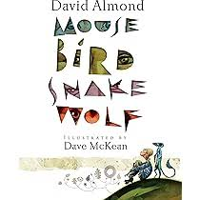  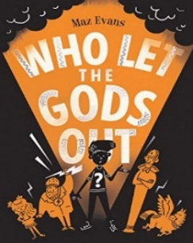 | 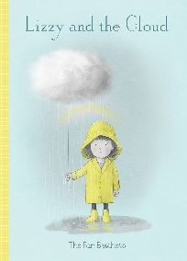  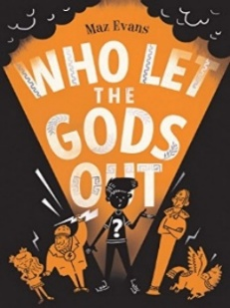
Writing | Narrative  Diary Entry  Letters  Newspaper report  Non-Fiction Report  Poetry  Recount | Narrative  Diary Entry  Letters  Instructions  Non-Fiction Report  Dialogue  Poetry
Grammar and punctuation | - Proper Nouns  - Adverbs of Probability  - Nouns/Adjectives into verbs -ate, -ise, -ify  - Past/Present Progressive and Present Perfect  - Possessive Plural  - Expanded Noun Phrases | - Adverbs  - Modal Verbs -Degrees of Possibility  - Verb Prefixes – dis-, de-, mis-, over-, re-  - Verb Inflections and Standard English  - Using Inverted Commas
Spelling | - Words ending with -tious and -ious  - Words ending in -cious  - Words ending in -cial  - Words ending in -tial  - Words ending in -cial and -tial  - Challenge - common exception words | - Words ending in -ant  - Words ending in -ance and -ancy  - Words ending in -ent and -ence  - Words ending in -able and -ible  - Words ending in -ably and -ibly  - Challenge – common exception words
Handwriting | Write legibly, fluently and with increasing speed by:  - Choosing which shape of a letter to use when given choices and deciding whether or not to join specific letters  - Choosing the writing implement that is best suited for the task | Write legibly, fluently and with increasing speed by:  - Choosing which shape of a letter to use when given choices and deciding whether or not to join specific letters  - Choosing the writing implement that is best suited for the task
Home | Children to read at least four times a week at home. This should be recorded in reading record book.  Children to access Spelling Shed online to learn spellings at least four times a week. | Children to read at least four times a week at home. This should be recorded in reading record book.  Children to access Spelling Shed online to learn spellings at least four times a week.

