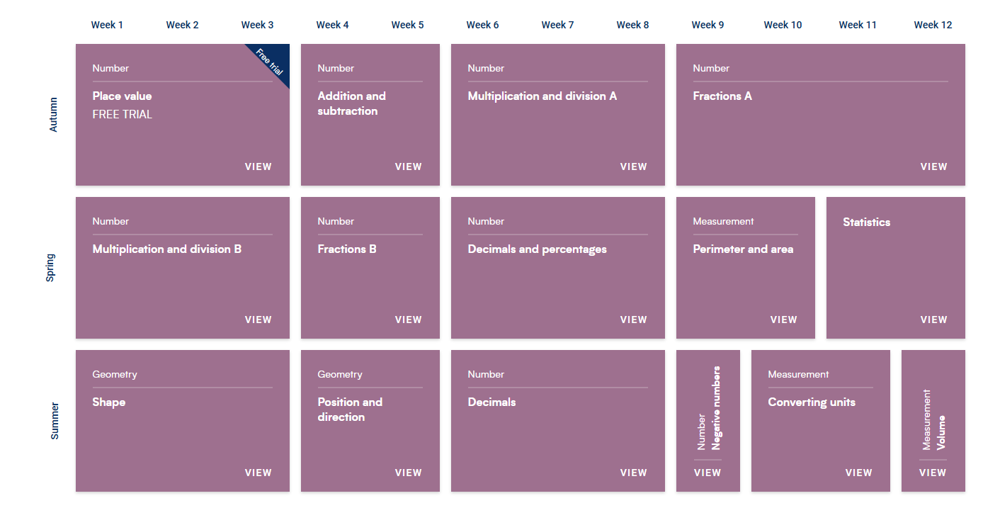
Year Five White Rose 2025-2026

