Saturn- Annual Curriculum Overview (2026 - 2027)
 | Autumn A | Autumn B | Spring A |  | Spring B | Summer A | Summer B
Topic | Magnificent Monarchs |  | Brave Explorers |  |  | The Great British Coast
Maths | 
English  Literacy Tree | - Narratives  - Stories  - Instructions  - Diary entry  - Letters  - Recount |  | - Narratives  - Stories  - Instructions  - Diary entry  - Letters  - Recount  - Non-fiction report  - Comparisons |  |  | - Narratives  - Stories  - Instructions  - Diary entry  - Letters  - Recount  - Non-fiction reports  - Poetry
Text | 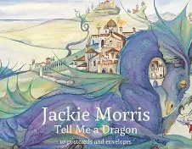  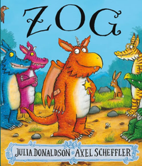  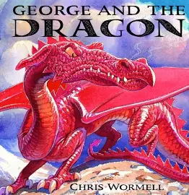  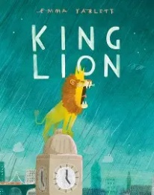  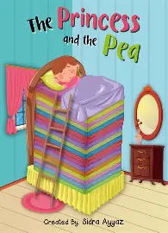 |  | 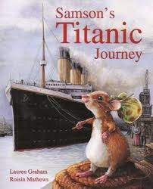  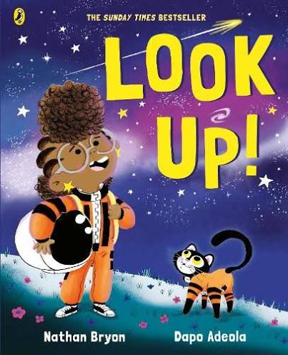  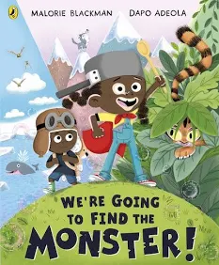  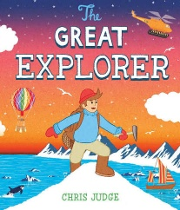 |  |  | 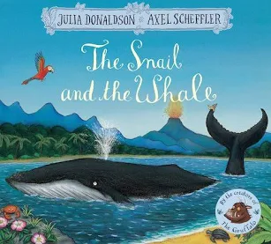  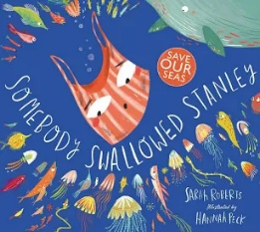  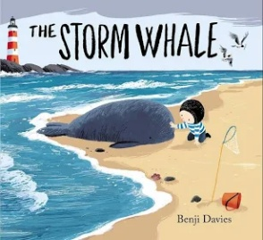  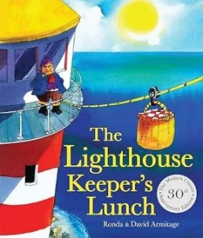
Science  Cornerstones | - Habitats (NC - Living Things and their habitats)  - Animals Survival (NC – Animals including humans) |  | - Uses of Materials (NC – Uses of everyday materials) |  |  | - Plant Survival (NC – Plants / Seasonal Changes)
History  Cornerstones | - Kings, Queens and Castles  - Power and rule  - Royal Residence  - Royal portraits  - Sovereigns’ timeline  - Significant people – Alfred the Great  - Significant people – William the Conqueror  - Hierarchy and power  - Significant people – Henry VIII  - Significant people – Elizabeth I  - Significant people – Queen Victoria |  | - Famous Explorers  - Exploring Impact  - Sorting and grouping  - Ranking significance  - Timelines  - The greatest explorers  - Significant people – Christopher Columbus  - Significant people – Neil Armstrong  - Timelines of significant people’s lives  - Exploration changes
Geography  Cornerstones |  |  | - My Local Area and Tromso, Norway  - Using an atlas  - Using compass directions  - Use a key with a map  - Collecting data  - Locating the equator  - Hot, temperature and cold places  - Sustainability |  |  | - The Coastline  - Map readers  - Reading Keys  - Physical process – Erosion  - Human features of a coastal town  - Coastal signs  - Remarkable RNLI  - Coastal rescue  - Saltwick Nab  Waves!
Computing  (NCCE) | - Computing systems and networks – IT around us.  - Creating media – Digital photography |  | - Programming A – Robot algorithms.  - Data and information – Pictograms. |  |  | - Creating media - Digital music  - Programming B - Programming quizzes.
Art | - Drawing – Van Gogh / Adonna Khares  - Colour – Monet / Matisse |  | - Texture – Ellen Jackson / Matisse / Linda Calverley  - Form – Jean Arp / Alexander Calder |  |  | - Printing – Kandinsky / Andy Warhol  - Pattern – William Morris / Gaudi
Music  Charanga  Sing Up  Sparkyard | - Weekly singing assembly  - Welcome Service  - Harvest Service  - Remembrance Service  - Christmas Carol Service  - Christmas Nativity performance  - Rhythm and Pulse |  |  | - Weekly singing assembly  - Mother's Day service  - Easter service  - Creating Rhythm |  | - Weekly singing assembly  - School concert  - Rhythm and pulse  - Creating Rhythm
DT | - Everyday fabric products  - Significant designer – Cath Kidston  - Sewing patterns  - Stitching  - Embellishment  - Machines and mechanisms  - Slider mechanism  - Lever mechanism  - Linkage mechanism |  | - Exploring where food comes from  - Tools  - Why do we cook our food?  Reading recipes |  |  | - Investigating beach huts  - Experimenting  - Working with wood
PSHE | - Be yourself  - Growing up |  | - It’s my body  - One world |  |  | - Safety first  - Very important people
RE | - Weekly Worship Assembly  - Welcome Service (School)  - Harvest Service (Church)  - Remembrance (School)  - Christmas Service (Church)  - Hindu - Navratri  - Christian – Christmas Story |  | - Weekly Worship Assembly  - Mother’s Day Service (Church)  - Easter Service (Church)  - Judaism – Hanukkah  - Buddhism - Losar |  |  | - Weekly Worship Assembly  - Leaver’s Service (School)  - Islamism – Jumu’ah  - Sikhism – Anand Karaj

