Neptune - Annual Curriculum Overview (2026- 27)
 | Autumn A |  | Autumn B | Spring A | Spring B | Summer A | Summer B
Topic | Ancient Civilisations |  |  | Misty Mountain, Winding River |  | Invasions
Maths | 
English  Literacy Shed | Setting description  Character description  Dialogue  Alternative endings  Instructions  Persuasion  Narrative retell  Diary entry  Newspaper  Poetry  Writing in role |  |  | Diary entry  Newspaper report  Persuasive  Recount  Recipe  Description  Poetry  Writing in role  Non fiction report |  | Explanation  Review  Newspaper report  Letter  Discussion  Play script  Explanation
Text | - Stitch Head by Gus Bass  - The Nothing to See Here Hotel by Steven Butler  - Ocean meets the Sky by The Fan Brothers  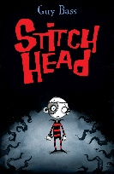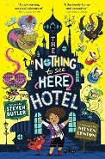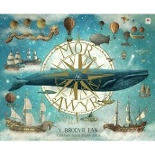 |  |  | - The Light in Everything by Katya Balen  - My Name is Not Refugee by Kate Milner  - Jack and the Beanstalk  - Jonty Gentoo by Julia Donaldson  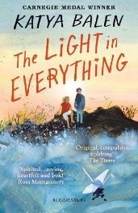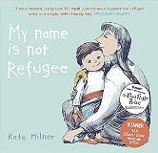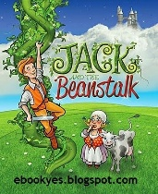  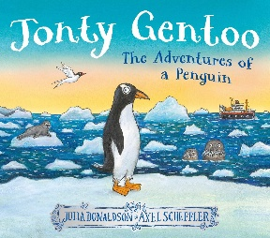 |  | - Superdad’s Day Off by Phil Earle  - The Earth book by Jonathon Litton  - The Baddies by Julia Donaldson  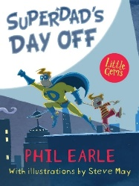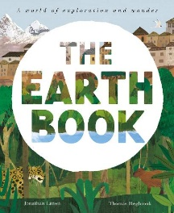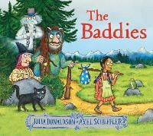
Guided reading  Literacy shed  Class reader | Oscar’s Lion |  |  | Secrets of the sun king |  | The boy at the back of the class
Science  Cornerstones | FOOD AND THE DIGESTIVE SYSTEM  - Understand the difference between biotic and abiotic features of ecosystems.  - Explore the different parts of food chains.  - Understand the effect changes in habitat have on the plants and animals within it.  - Identify the parts of the digestive system within our bodies.  - Explore the adaptations between species.  - Understand how to care for our teeth.  SOUND  - Identify how sounds are made, associating some of the with something vibrating.  - Recognising that vibrations from sounds travel through a medium to the ear.  - Find patterns between the pitch of a sound and features of the object that produced it.  - Find patterns between the volume of a sound and the strength of the vibrations that produced it.  - Recognise that sounds get fainter as the distance form the sound source increases. |  |  | GROUPING AND CLASSIFYING  - Make systematic and careful observations.  - Identify similarities and differences within plants/animals in order to classify.  - Understand the importance of classification within the natural world.  Sort plants /animals using classification keys.  STATES OF MATTER  - Understand the differences between gas, liquid and solid.  - Explore the effect that temperature has on solids, liquids and gas.  - Collect and interpret data through observation.  - WATER CYCLE |  | STATES OF MATTER  - Understand the differences between gas, liquid and solid.  - Explore the effect that temperature has on solids, liquids and gas.  - Collect and interpret data through observation.  - WATER CYCLE  ELECTRIC CIRCUITS AND CONDUCTORS  - Understand the properties needed to create a circuit.  - Recognise a switch open and closes the circuit.  - Recognise the difference between materials that conduct electricity (conductors) and those that don’t (insulators)
History  Cornerstones | Ancient Civilisation  - The achievements of the earliest civilisations – an overview of where and when the first civilizations appeared and a depth study of Ancient Sumer, looking at similarities and differences with Ancient Egyptians. |  |  |  |  | Invasion  - Britian’s settlements by Anglo-Saxons and Scots  - Struggles between Anglo-Saxons and Vikings until 1066.  - A local history study
Geography  Cornerstones | - Location of ancient civilisations  - Rivers and seas of ancient civilisations  - Climate of ancient civilisations |  |  | Misty Mountains, Winding River  - Rivers  - Maps  - Grid references  - Contour lines  - Physical processes – erosion, transportation and deposition  - World rivers  - Aerial images  - Mountains  - UK mountains/World mountains  - Compass points  - Water cycle  - Soil  - Altitudinal zones |  | - Location of the Saxons, Angles, Jutes, Scots, Welsh etc  - Counties of Britain
Computing  (NCCE) | - Computing Systems and Networks – the internet  - Creating Media – audio production |  |  | - Programming A – repetition in shapes  - Data and Information – data logging |  | - Creating Media – photo editing  - Programming B – repetition in games
Art | Drawing  Identify and draw the effect of light (shadows) on a surface, on objects and people – look at Pierre-Yves Riveau.  Introduce the concepts of scale and proportion. Continue to use graded pencils.  Colour  Observe colours on hands and faces - mix flesh colours – look at Lucien Freud’s portraits.  Use colour to reflect mood. |  |  | Texture Use a wider variety of stitches to 'draw' with and develop pattern and texture – e.g. zig zag stitch, chain stitch, seeding.  Look at fabrics from other countries and discuss. Compare with own. Discuss different types of fabric – look at Jill Denton’s recycled mixed-media collection.  Form  Plan and develop ideas in sketchbook and make informed choices about media.  Discuss own work and work of other sculptors with comparisons made – Look at Henri Moore’s sculpture.  Investigate, analyse and interpret natural and manmade forms of construction – look at Gaudi’s architecture |  | Printing  Use sketchbook for recording textures/patterns.  Interpret environmental and manmade patterns and form.  Explore images and recreate texture through deliberate selection of materials - wallpaper, string, polystyrene etc- look at Hiroshige’s prints.  Pattern  Look at various artists creation of pattern and discuss effect – Mondrian, Gaudi
Music  Charanga  Sing Up | - Weekly singing assembly  - Welcome Service  - Harvest Service  - Remembrance Service  - Christmas Carol Service |  |  | - Somerset Music - Violins  - Weekly singing assembly  - Mother's Day service  - Easter service |  | - Somerset Music - Violins  - Weekly singing assembly  - School concert
Spanish  Bitesize and twinkl | - Colours  - Numbers  - Days of the week  - Months  - School subjects  - Festive jumpers |  |  | - Healthy eating  - Going to the market  - Healthy recipe  - Clothes  - Fancy dress |  | - Out of this world  - At the seaside  - In the city  - Shopping
DT  Cornerstones | Fresh food, Good food  This project teaches children about food decay and preservation. They discover key inventions in food preservation and packaging, then make examples. The children prepare, package and evaluate a healthy snack. |  |  | Functional and fancy fabrics  This project teaches children about home furnishings and the significant designer William Morris. They learn techniques for decorating fabric, including block printing, hemming and embroidery and use them to design and make a fabric sample. |  | Tomb builders  This project teaches children about simple machines, including wheels, axles, inclined planes, pulleys and levers, exploring how they helped ancient builders to lift and move heavy loads.
PE  TLE | Football |  | Dance/Gym | Hockey | Netball | Athletics | Cricket
PSHE  Twinkl | - Very Important People  - Be Yourself |  |  | - Think Positive  - Diverse Britain |  | - It’s my body  - Safety First
RE –  Cornerstones and  Christianity every other week | Buddhism – kathina  Kathina is a Buddhist celebration held after Vassa.  Vassa is a period of retreat, meditation and studying the Dharma.  Communities give new robes to monks who complete Vassa.  Giving robes is believed to create good karma.  Kathina is named after a traditional sewing frame. | Janmashtami  Janmashtami celebrates the birth of Lord Krishna.  It takes place in August or September.  The festival lasts two days.  Hindus may sing, dance, tell stories and rock Krishna’s cradle.  Some Hindus fast until midnight to celebrate Krishna’s birth. |  | Eid ul-Adha – Islam  Eid ul-Adha is known as the Greater Eid.  It remembers Prophet Ibrahim’s obedience to Allah.  Ibrahim was willing to sacrifice his son Isma’il.  Allah provided a ram to sacrifice instead.  Eid ul-Adha takes place at the end of Hajj. | Holy week and Easter – Christianity  Holy Week is the last week of Lent.  It begins with Palm Sunday, remembering Jesus arriving in Jerusalem.  Good Friday remembers Jesus’ crucifixion.  Easter Sunday celebrates Jesus’ resurrection.  Christians may celebrate with church services, candles, food and Easter eggs. | Shabbat – Judaism  Shabbat is the Jewish day of rest.  It begins at sunset on Friday and ends on Saturday.  Jews may rest, spend time with family, eat special meals and attend synagogue.  Shabbat is based on the belief that God rested on the seventh day.  Families prepare beforehand and follow rules to keep Shabbat as a day of rest.  . |  | Sikhism – Vaisakhi  Vaisakhi is celebrated by Sikhs on 13th or 14th April.  In 1699, Guru Gobind Singh created the Khalsa.  The Khalsa are Sikhs who commit to following the Sikh faith and wearing the Five Ks.  Vaisakhi may include Nagar Kirtan, langar, dancing and martial arts.  Vaisakhi is also a New Year and harvest festival in Punjab.

